**Web and Internet**

**Class Six**

**Lab 11**

|  |
| --- |
| Lab Objectives:  * Create Account * Sign up |

# Getting started with email

## You should now have a good understanding of what email is all about.

# Setting up your own email account

## If you want to sign up for your own email account, we suggest choosing from one of the three major webmail providers.

## Gmail

## Outlook.com (Hotmail)

## Yahoo! Mail

In this lab we will follow Google’s Gmail.

# Introduction

## Setting up a Gmail account is easy. You will begin by creating a Google account, and during the quick sign-up process you will choose your Gmail account name. In this lesson, we'll show you how to set up your Google account for Gmail.

# Setting up a Gmail account

## To create a Gmail address, you'll first need to create a Google account. Gmail will redirect you to the Google account sign-up page. You'll need to provide some basic information like your name, birth date, gender, and location. You will also need to choose a name for your new Gmail address. Once you create an account, you'll be able to start adding contacts and adjusting your mail settings.

### To create an account:

1. Open any of your web browser

## Go to [www.gmail.com](http://www.gmail.com)

## Click Create account

After clicking a signup form will appear

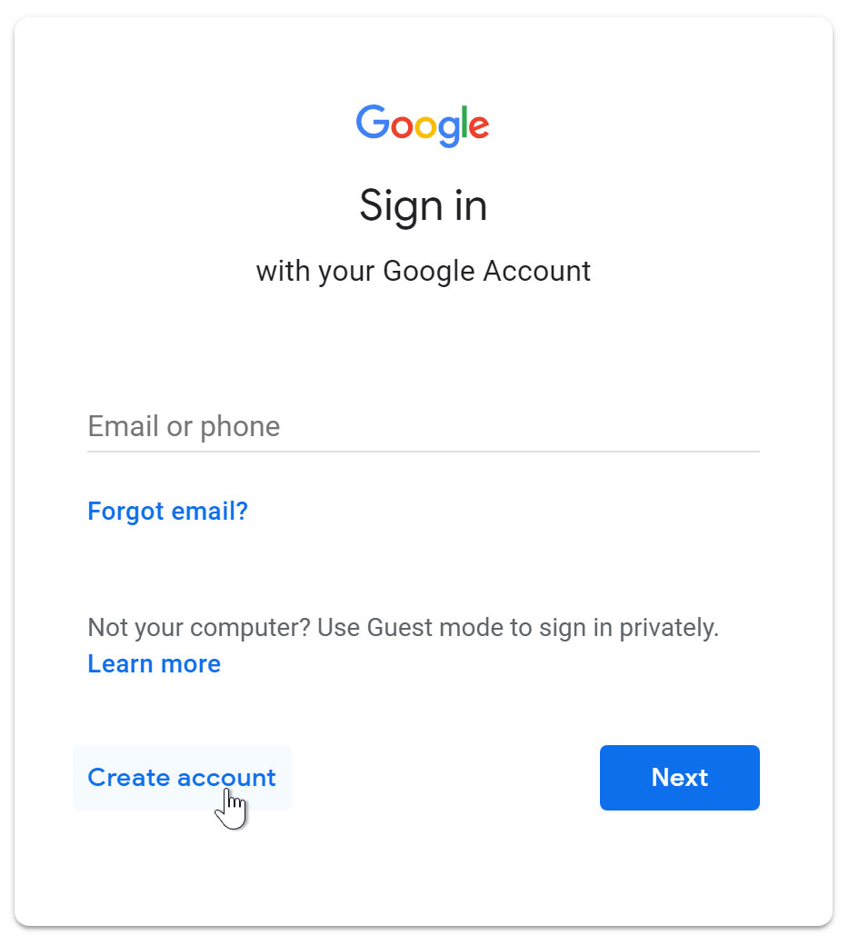

## Follow the directions by entering the required information.

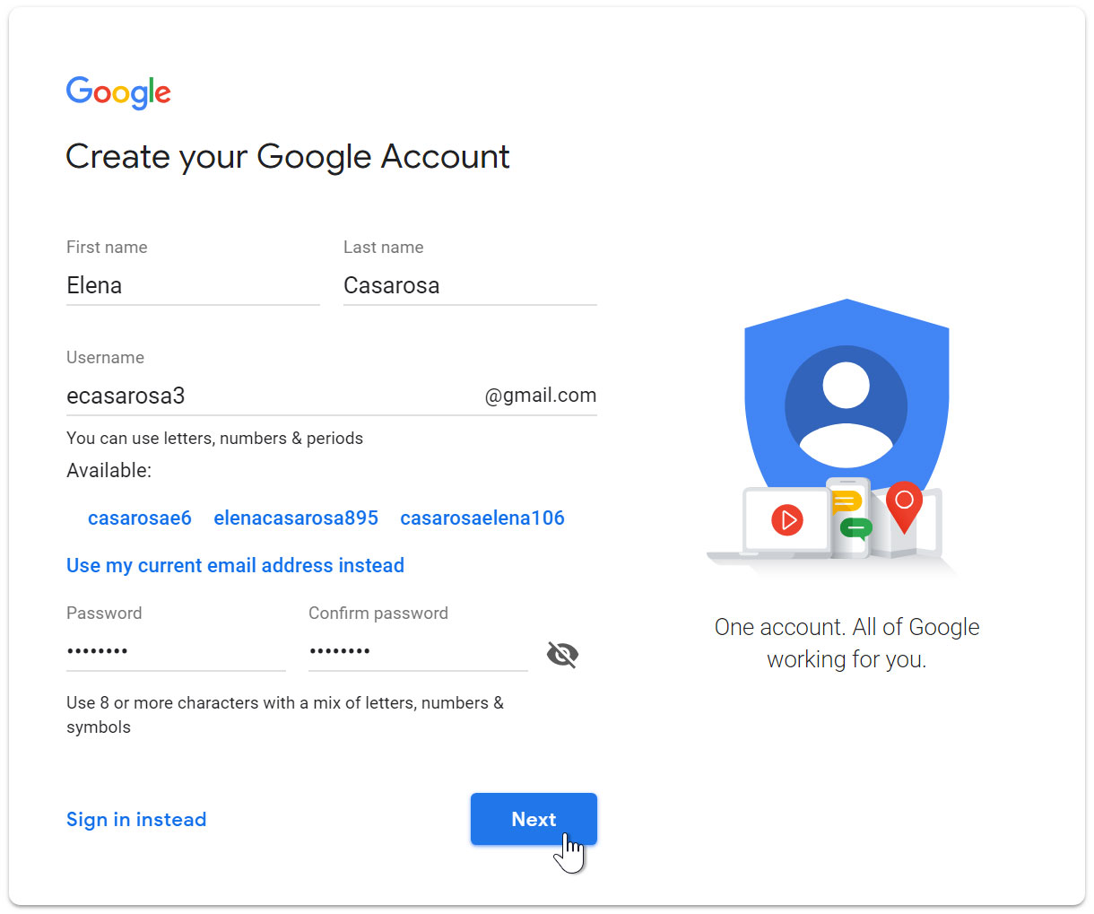

## Next, enter your phone number to verify your account.

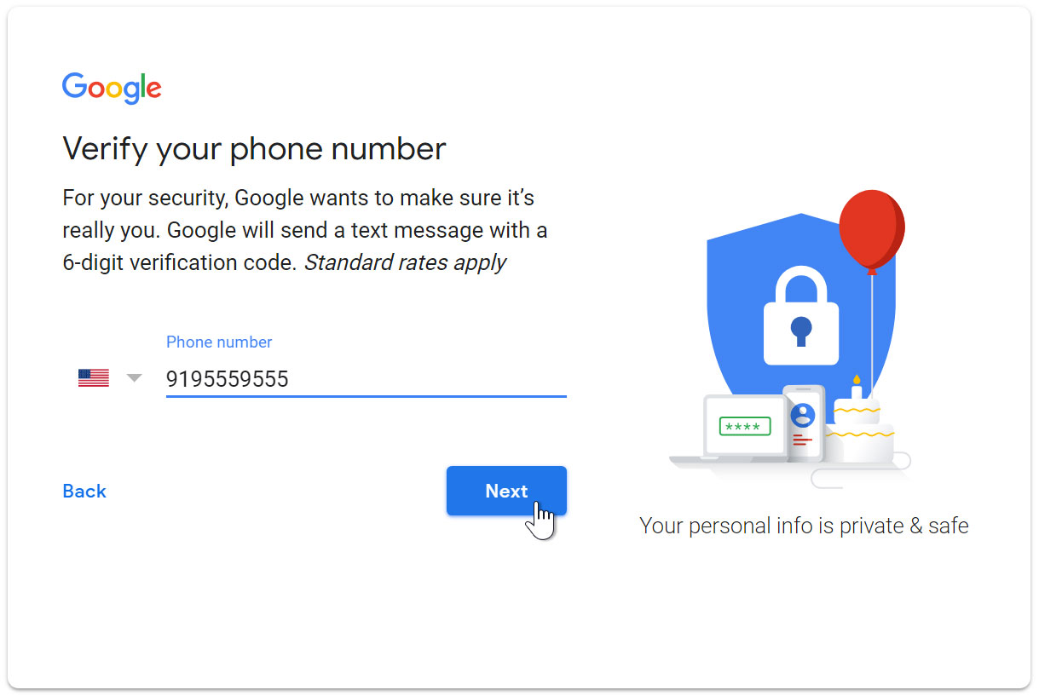

1. You will receive a text message from Google with a verification code. Enter the code to complete the account verification.

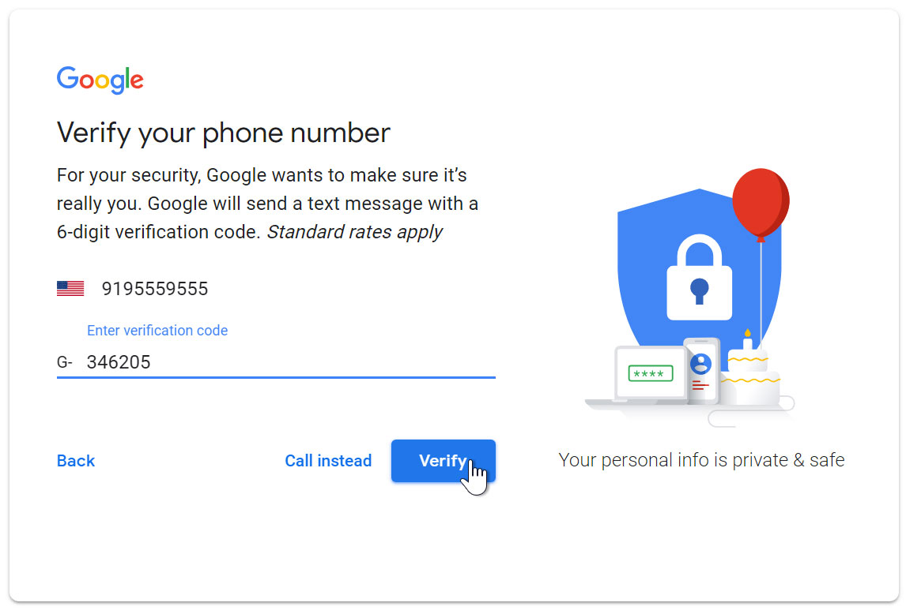

## Next, you will see a form to enter some of your personal information, like your name and birthday

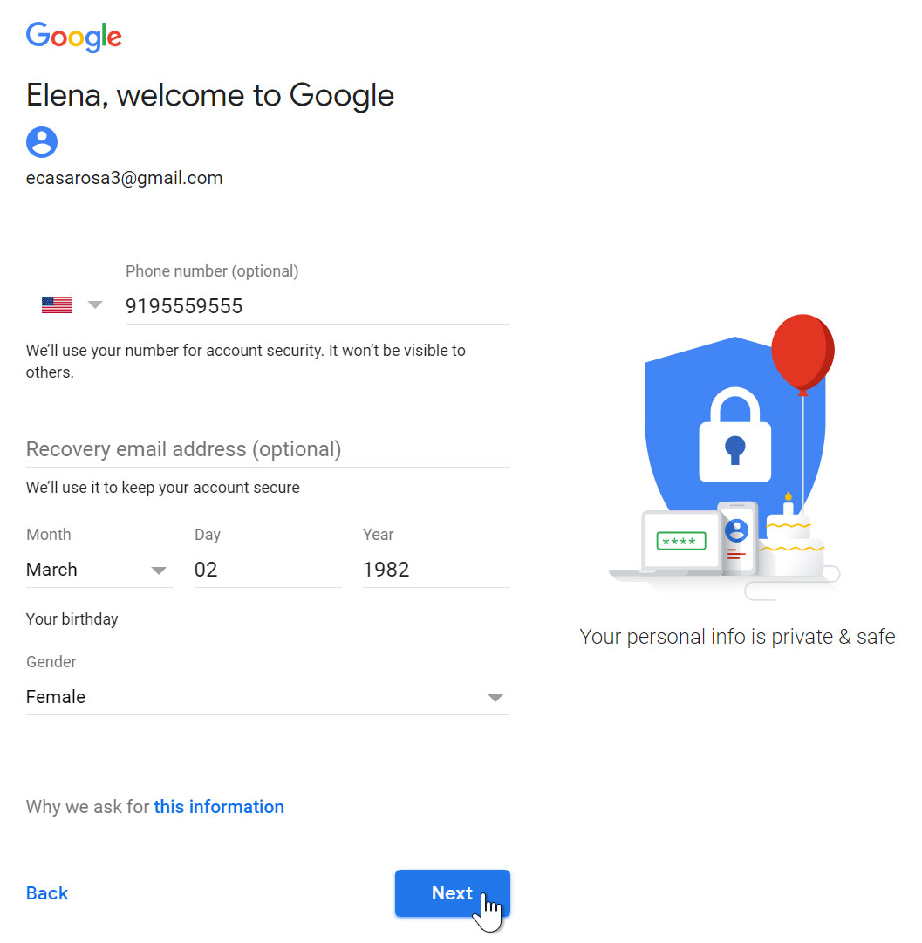

## Review [Google's Terms of Service](http://www.google.com/intl/en/policies/terms/" \t "/home/deepto/Documents\\x/_blank) and [Privacy Policy](http://www.google.com/intl/en/policies/privacy/" \t "/home/deepto/Documents\\x/_blank), then click I agree.

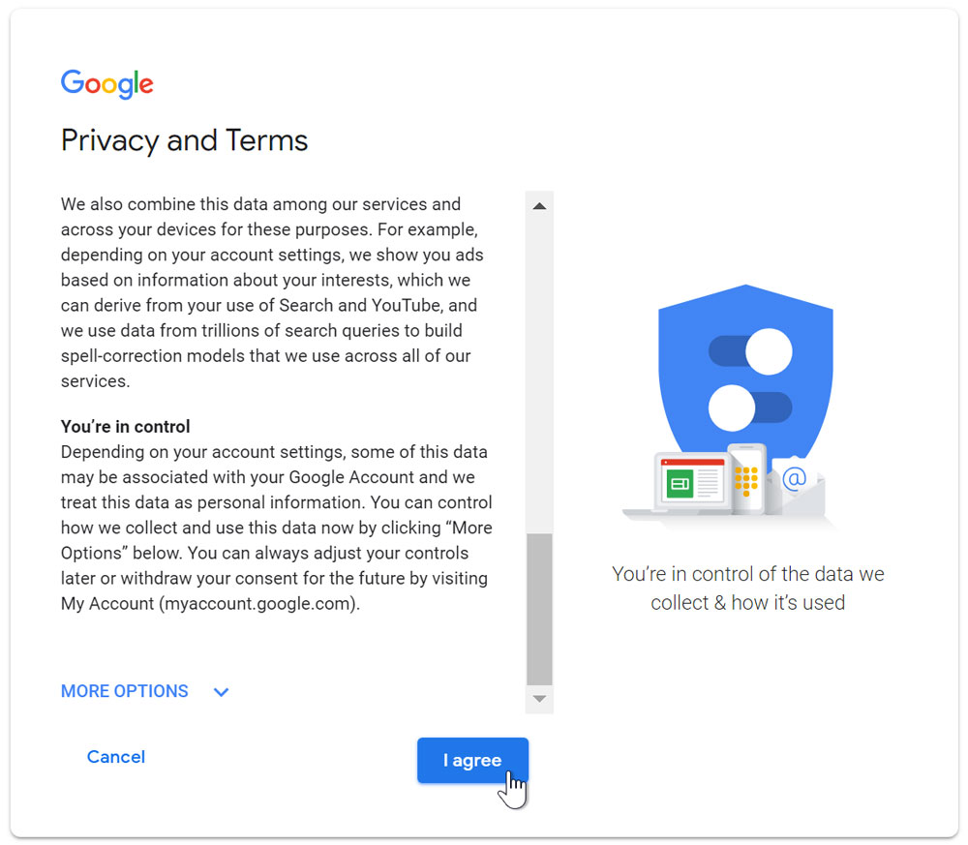

## Your account will be created.

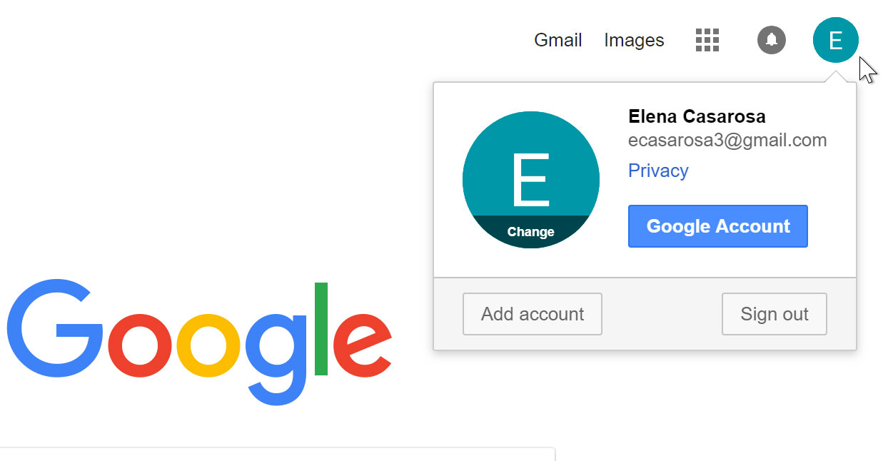

## IMG_256 Just like with any online service, it's important to choose a strong password—in other words, one that is difficult for someone else to guess.

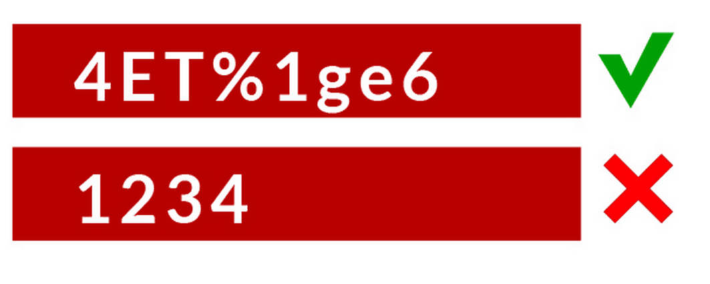

# Signing in to your account

## When you first create your account, you will be automatically signed in. Most of the time, however, you'll need to sign in to your account and sign out when you're done with it.

## Signing out is especially important if you're using a shared computer (for example, at a library or office) because it prevents others from viewing your emails.

### To sign in:

## Go to [www.gmail.com](http://www.gmail.com" \t "/home/deepto/Documents\\x/_blank).

## 1Type your user name (your email address) and password, then click Next.

### To sign out:

## In the top-right corner of the page, locate the circle that has your first initial (if you've already selected an avatar image, it will show the image instead). To sign out, click the circle and select Sign out.

